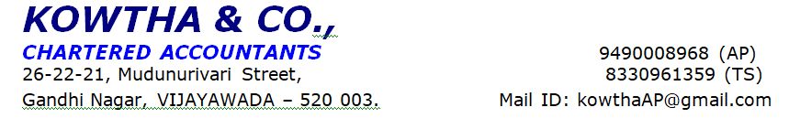
PERSONAL DISCUSSION SHEET

Region |  |  |  | Location |  |  |  |  | Branch |  |  |  |  |  | Ref No/Application No
Indian |  |  |  |  |  |  |  |  | Andhra Pradesh |  |  |  |  |  | BLA00045382
Name of Customer | Mr. XXXX
Date of Report | 14-05-2025
Name of Concern | M/s. XXXX
Constitution | proprietorship
Initiated Address | XXXXX
Visited Address | XXXX
Phone no. | XXX
Appointment Fixed | 14-05-2025
Structure of Loan
No. of Visit | This is the First Visit to the Applicant
Person Met | Mr. XXX
Visited By | Mr. XXX
About Applicant | The applicant is Mr. XXXX, he aged 33 years has studied Inter and native of Vizianagaram. He is living with his family at owned house.
Residential Details | XXXXX
Co-Applicant Details
Family Details:
Name |  | Relation with Applicant |  |  | Age(Yrs) |  | Qualification |  |  |  |  | Occupation |  |  |  |  | Income per month (approx.) |  |  | Dependent
XX |  | Wife |  |  | 26 years |  | Graduate |  |  |  |  | Business
XX |  | Son |  |  | 3 years
XX |  | Father |  |  | 55 years |  | Below 10th
XX |  | Mother |  |  | 50 years |  | - |  |  |  |  | House wife
Constitution
Shareholding Details:
Name of the Shareholder | Relation with Main Applicant |  |  | Designation |  |  |  | % of Shareholding |  |  |  |  | Coming into Loan Structure |  |  | Functional of Partner / Director
About the Business: | - M/S. XXX firm has started by the applicant Mr. XXXX in the year 2016 and managing the whole business activities  - It is a sole proprietorship business concern and he manages all business activities  - He has 10+ years of experience in this business  - This business is registered under GST in the year 2019  - Nature of the business is Coco- cola & Beverages Distributer.  - He sells Thump-up, Sprite, Fanta, Gluco, Maaza, Soda, Limca and water bottle in this business premises.  - He charges Rs. 500 per Tray which contain 24 pieces each Capacity bottle 25 ML, Rs. 840 per Tray which contain 9 pieces each Capacity bottle 2.25ML and Rs. 240 per Tray which contain 12 pieces each Capacity bottle 1 liter Etc.  - He purchases the stock from Coco- cola company at Vizag  - He is running business in owned premises  - There are 03 workers are working under this business 01 Driver and he pay Rs. 20,000 and 02 Helper and he pay Rs. 20,000/- pm.  - He maintained stock worth Rs.30,00,000+/- at business premises at the time of visit  - He has 02 own commercial transport vehicle, but vehicle RC not provided and he using the vehicle business purpose  - Major business transactions are done through cash/online in his business  - Not provided any documents  - Customers are general public, Retails, Pan shop, Restaurant, Dhaba Etc.
Documents Observed:
Document Category |  |  |  | Document Name |  |  |  |  |  |  | Document Type |  |  |  |  | Remarks
 |  |  |  | GST & Bill |  |  |  |  |  |  | - |  |  |  |  | -
 |  |  |  |  |  |  |  |  |  |  | - |  |  |  |  | -
Suppliers/Creditors
No of Fixed Suppliers | No
Credit Period | No
Cash-Cheque Proportion | No
Name (top 3 Suppliers) |  |  |  | Contact Details |  |  |  |  |  |  | Location |  |  |  |  | Ref. Check
 |  |  |  |  |  |  |  |  |  |  |  |  |  |  |  | -
 |  |  |  |  |  |  |  |  |  |  |  |  |  |  |  | -
Clients/Debtors
No of Fixed Customers
Credit Period | -
Cash-Cheque Proportion | NA
Name (top 3 Customers) |  |  |  | Contact Details |  |  |  |  |  |  | Location |  |  |  |  | Ref. Check
 |  |  |  |  |  |  |  |  |  |  |  |  |  |  |  | -
 |  |  |  |  |  |  |  |  |  |  |  |  |  |  |  | -
Average Stock Maintained | Rs. 30,00,000+/-
Turnover & Margins: | Rs. 25,00,000/- Margin:- 9%
Expenditure
Salaries & Wages
No. of Employees | Salary per  month per  Employee |  |  | Status of  Employee |  |  |  | No. of Labours |  |  |  |  | Wages per  month / per day |  |  |  |  | Status of  Labour |  | Remarks
03 Members | - |  |  | - |  |  |  |  |  |  |  |  |  |  |  |  |  | - |  | -
Working Hours: | -
Other Major Exp. & Basis: | Nil
Asset Details:
All Immovable properties held that is Residential, Commercial, Land, Plot and any fixed structure:
Address | Area  Measurements |  |  | Purchase  Cost (in  Lakhs) |  |  |  | Purchase  Year |  |  |  |  | Market  Value (in  Lakhs) |  |  | Owner Name |  |  |  | Mortgaged (Yes/No)
Not given |  |  |  | - |  |  |  | - |  |  |  |  | - |  |  | - |  |  |  | -
Any Liquid, Moveable & Monetary items such as Cash,  Gold, FD, RD, Mutual Fund Holdings, Shares, Bonds,  Securities |  |  |  |  |  |  |  | NA
Life Insurance, Mediclaim, Property/Asset Insurance  (Premium & Sum Assured) |  |  |  |  |  |  |  | NA
Capital invested in any business, Loans & Advances  given |  |  |  |  |  |  |  | NA
Car, Bike and any other vehicle (Company Name and  Model) |  |  |  |  |  |  |  | NA
Note: Amounts mentioned above are approx.
Loan Details:
Name of  Bank /  NBFC |  |  | Type of  Loan |  |  | Sanctioned  Amount  (in Lakhs |  |  |  | O/S  Balance  (in  Lakhs) |  |  |  | EMI (in  Rs.) |  |  |  |  | EMI Paid  Bank | Secured  Against  which  Asset
IDFC |  |  | OD loan |  |  | Total loan Amount- 13  (7 Business loan)  (LAP- 5)  (1-Car) |  |  |  |  |  |  |  | Total EMI- 4.8 Lakhs
Bank Details
Bank Name |  |  |  | Branch Name |  |  |  | Account Type |  |  |  |  |  |  |  | Open Since (Year)
SBI |  |  |  |  |  |  |  | Current
End Use of Loan:(Loan Amount & Detailed End-Use) |  |  |  | Business Development
Third Party Check:
Individual /  Business Name |  |  | Address |  |  |  |  | Contact No |  |  |  |  | Knowing Since |  |  | Feedback on  Borrower |  |  |  | Feedback on  Business
 |  |  |  |  |  |  |  | D. Sai- 9618030457
 |  |  |  |  |  |  |  | S. Teja- 9502090662
Observation: |  |  | - Business name board is seen  - GST & Bill
Other Income: (Income from other than initiated business) |  |  | - NA
Site Coordinates:
Remarks: |  |  | Not provided bank statement, RC vehicle, Driving license, Labour license  Applicant said that all documents submitted to the bank
Status: |  |  | Credit Refer ( Not provided documents)
AFL Verifier's Name & Emp Code: |  |  | Mr. XXX |  |  |  |  |  |  |  | AFL Verifier's Signature |  |  |  |  | Mr. XXXX

Disclaimer clause: -
The Report (Including any attachments) has been prepared on the basis of verbal information provided by the person contacted. Axis Finance Limited will be solely responsible for any actions taken on this report and any liabilities directly or indirectly accruing from such actions, efficient services will not be liable in any case.

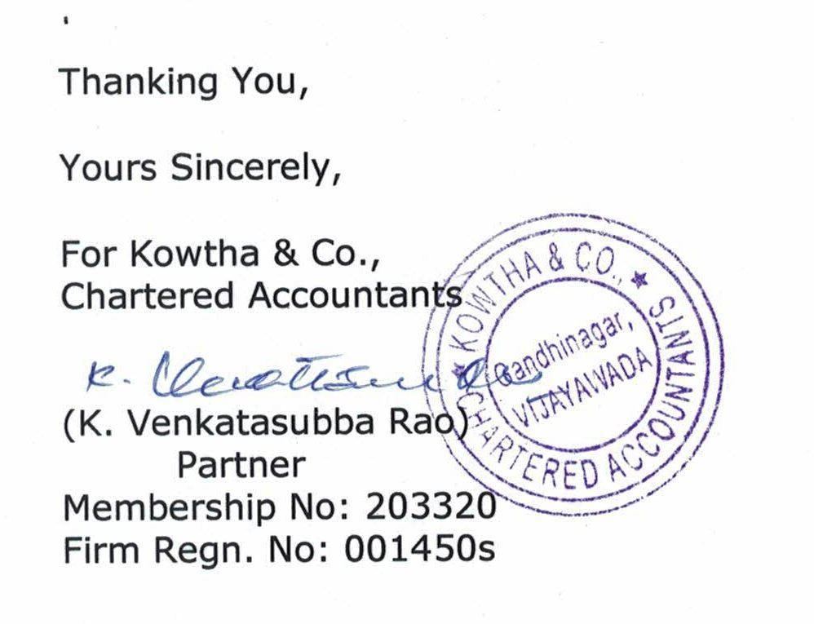

Photos:

